CS 340 Project Two README

About the Project/Project Title
Grazioso Salvare Web Application Dashboard
This dashboard is designed to assist Grazioso Salvare in identifying suitable dogs for search-and-rescue training based on existing data from five animal shelters. It provides a user-friendly interface for filtering, categorizing, and visualizing animal information.

Motivation
The motivation behind the Grazioso Salvare web app is to streamline the process of identifying suitable dogs for search-and-rescue training. As part of its work, Grazioso Salvare identifies dogs that are good candidates for search-and-rescue training. When trained, these dogs are able to find and help to rescue humans or other animals, often in life-threatening conditions. To help identify dogs for training, Grazioso Salvare has reached an agreement with a non-profit agency that operates five animal shelters in the region around Austin, Texas. This non-profit agency will provide Grazioso Salvare with the existing data from their shelters.

Getting Started
To get started with the CRUD module and connect to the Austin Animal Center (AAC) database, follow these steps:
- Install Python 3.6 or later
- Install MongoDB
- Set Up the MongoDB Environment:
  - start the MongoDB service using mongosh
  - Create a user account named "aacuser" with appropriate permissions.
  - Import the "aac_shelter_outcomes.csv" dataset into a MongoDB database named "AAC" and a collection named "animals" using the mongoimport tool.
- Clone or Download the Project:
  - Obtain the source code for the mongodb_crud.py file
- Install Dependencies:
  - Install the required Python library pymongo using pip install pymongo.
- Import Module:
  - Import the AnimalShelter class from mongodb_crud.py into your Python script.
- Connect to Database
  - Create an instance of the AnimalShelter class
    - For example: database = AnimalShelter(username, password)

Usage
How to use the CRUD Module:
- create(document): Inserts a new document into the specified collection. Returns True on success, False on failure.
- read(query): Retrieves documents matching the specified query. Returns a list of documents.
- readAll(query): Retrieves all documents or filtered documents based on the provided query, and returns a cursor object.
- update(query, update_data): Modifies documents matching the query with the provided update data. Returns the number of modified documents.
- delete(query): Removes documents matching the query. Returns the number of deleted documents.
Tests:
Follow these steps to test the module using Jupyter Notebook
- Import the module:
  - from mongodb_crud import AnimalShelter
- Instantiate an object:
  - object = AnimalShelter()
- Create a document:
  - object.create(document)
- Read a document:
  - object.read(query)
- Read documents with a filtered query
  - object.readAll(query)
- Update a document
  - object.update(query, update_data)
- Delete a document:
  - object.delete(query)

Dashboard Functionality (Screenshots)

Landing Page: Grazioso Salvare web application landing page before any filters
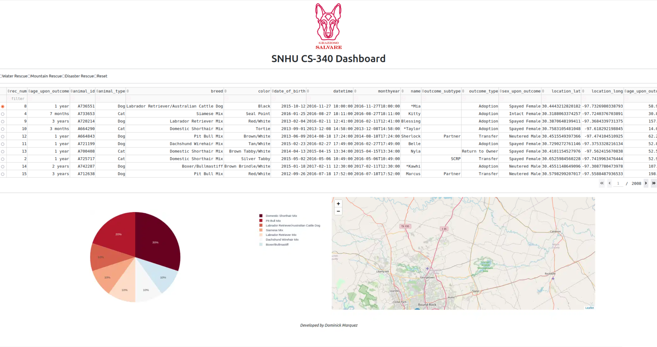

Filter: Water Rescue
The water rescue filter displays intact female dogs that meet the requirements for water rescue in the table. The preferred dog breeds are Labrador Retriever Mix, Chesapeake Bay Retriever, and Newfoundland. The preferred training age is 26 to 156 weeks.
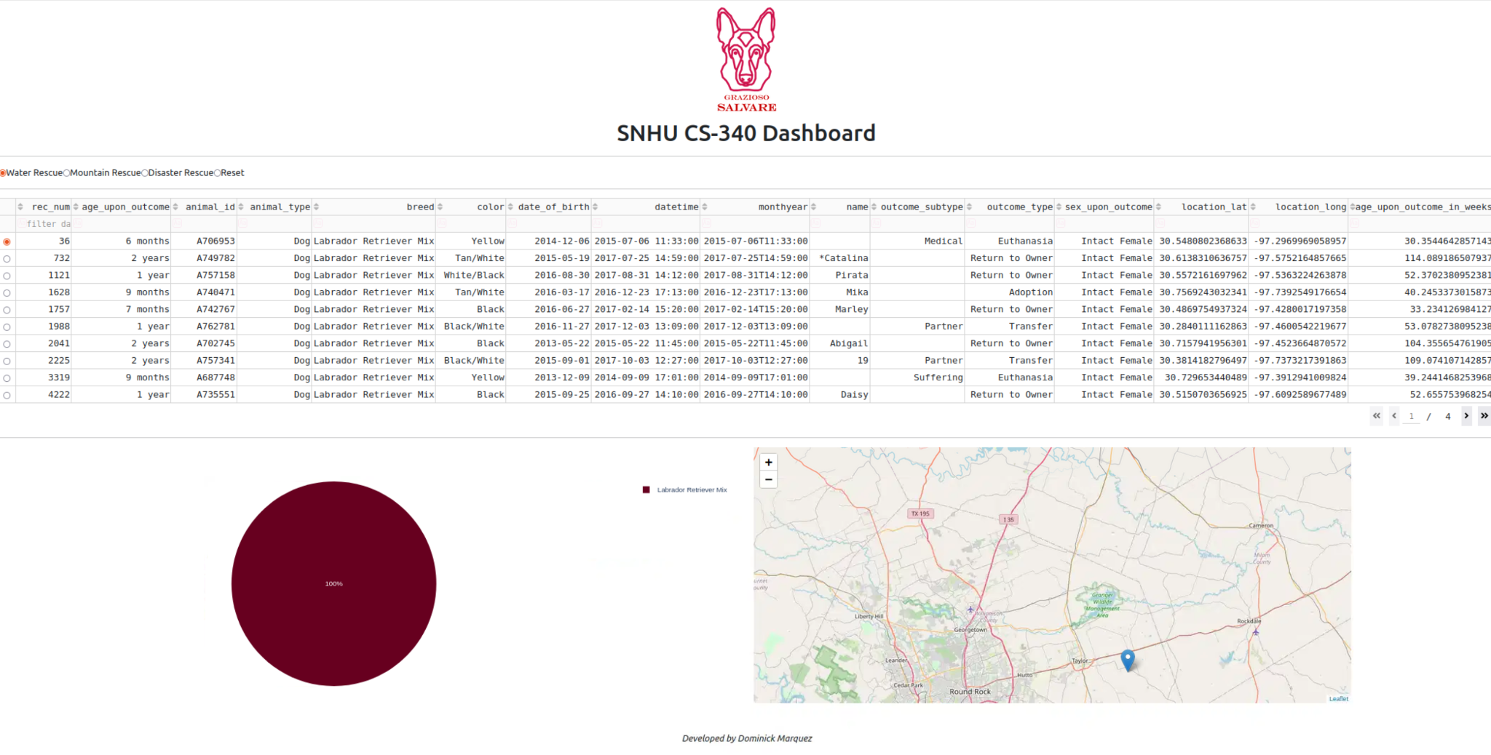
Filter: Mountain Rescue
The mountain rescue filter displays intact male dogs that meet the requirements for mountain or wilderness rescue. The preferred dog breeds are German Shepherd, Alaskan Malamute, Old English Sheepdog, Siberian Husky, and Rottweiler. The preferred training age is 26 to 156 weeks.
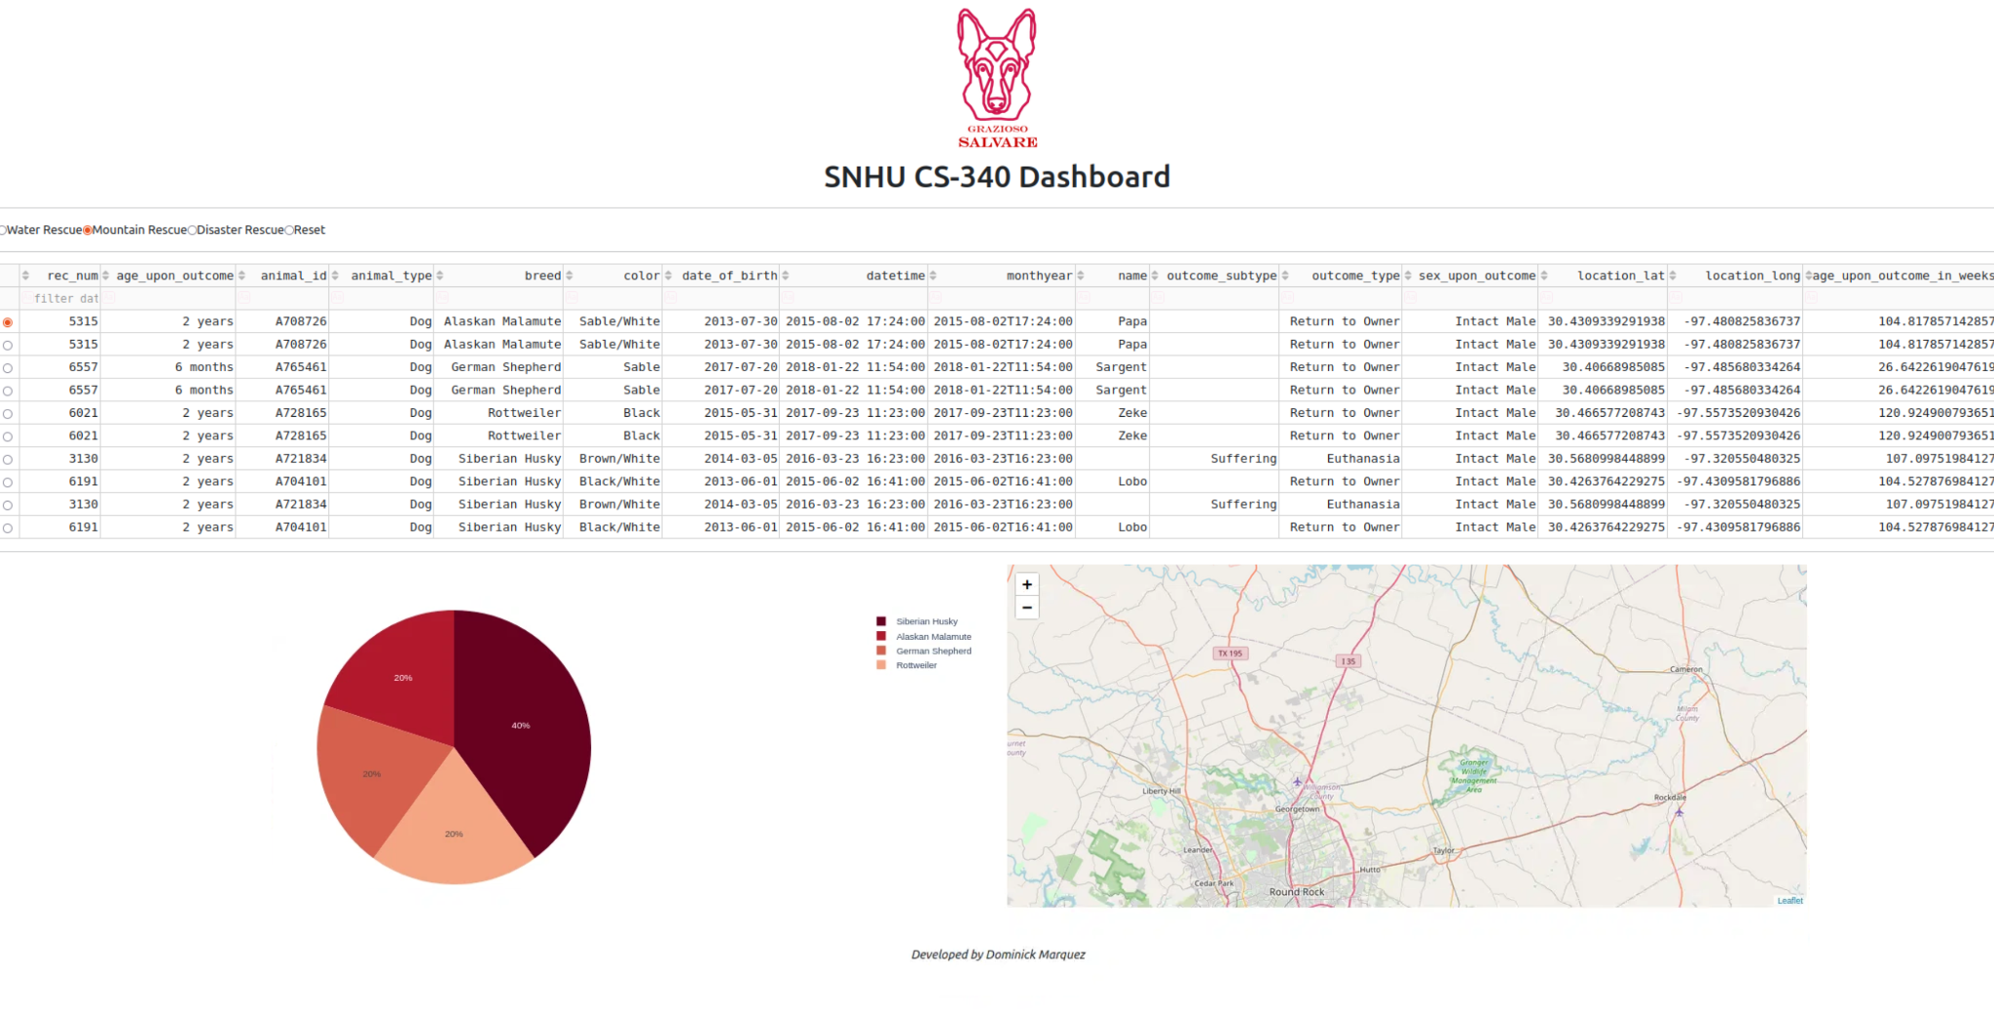

Filter: Disaster Rescue
The disaster rescue filter displays intact male dogs that meet the requirements for disaster and individual tracking. The preferred dog breeds are Doberman Pinscher, German Shepherd, Golden Retriever, Bloodhound, and Rottweiler. The preferred training age is 20 to 300 weeks.
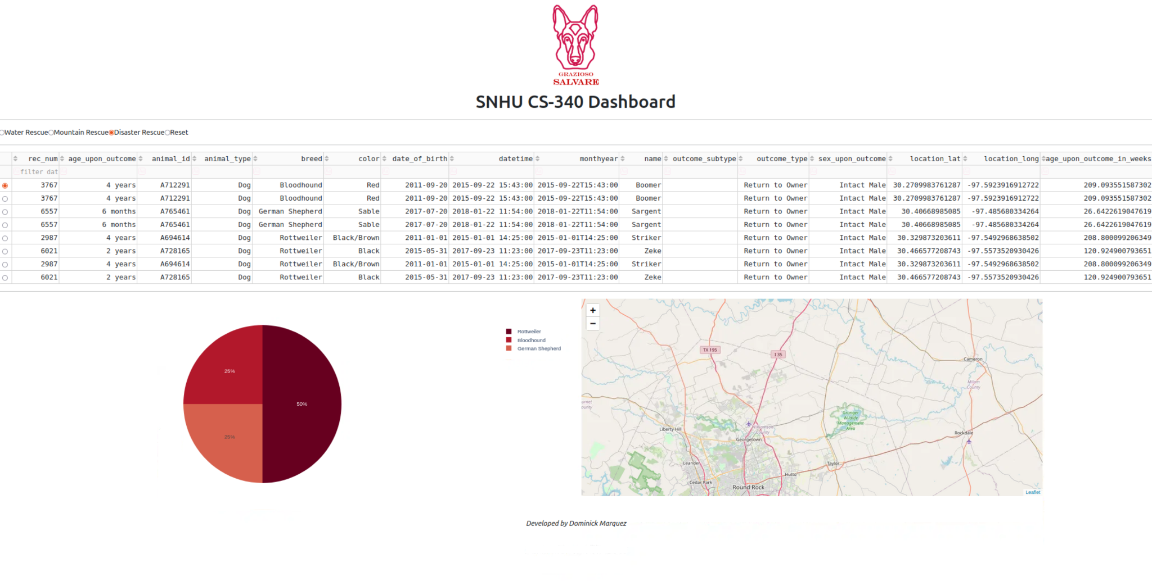

Filter: Reset
The reset filter returns all widgets to their original, unfiltered state
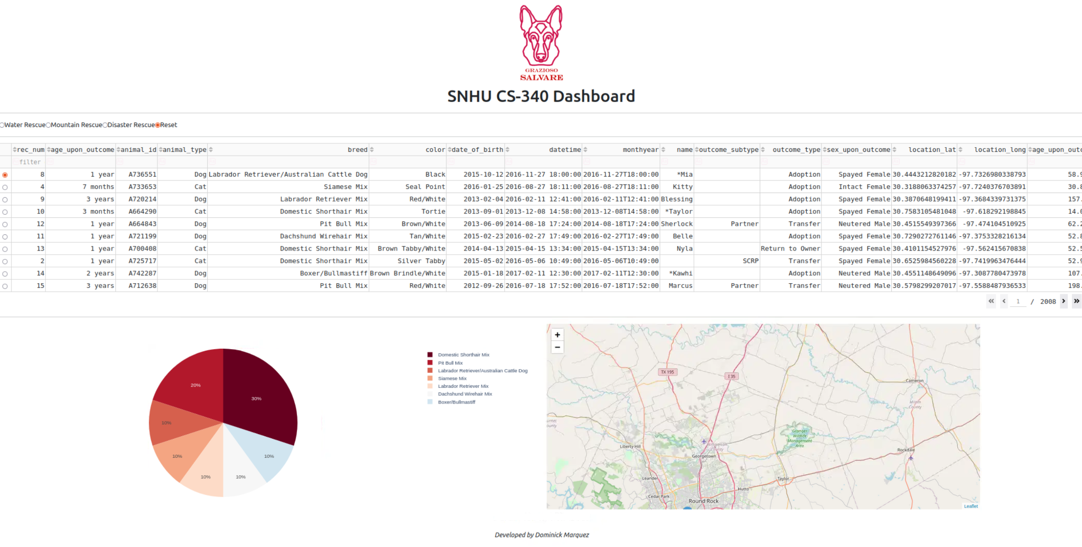

Tools
- Python: The programming language used for the CRUD module.
- pymongo: The Python driver for MongoDB, used to interact with the database.
- MongoDB: The NoSQL database used to store animal shelter data.
- Jupyter Notebook: Server-client application used for testing the CRUD module.

Rationale behind tools used:
- Python(Programming Language): Python's readability and flexibility make it ideal for rapid development and prototyping. Python also has a large and active community, which ensures ongoing development, support, and a wealth of resources.
- pymong (Python driver): As the official Python driver for MongoDB, pymongo offers seamless integration and optimal performance. Pymongo ensures fast and responsive database interactions by providing efficient communication with MongoDB servers. It also provides a full range of functionalities for interacting with MongoDB databases, including CRUD operations, aggregation, and indexing. By utilizing pymongo, we can effectively leverage the capabilities of MongoDB within our Python application and efficiently manage animal shelter data for the Grazioso Salvare project.
- MongoDB(Database): The document-oriented structure aligns well with the hierarchical nature of animal data, simplifying data storage and retrieval.
- Jupyter Notebook(Server-client Application): Jupyter Notebook enables data analysis, code testing, and visualization in a single environment. It can also be shared and collaborated on, fostering knowledge sharing and teamwork.

Contact
Dominick Marquez

